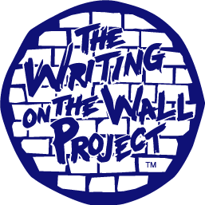

To write a new future we must build a new foundation by first tearing down the shameful structures of oppression and discrimination

Table of Contents

Iota Psi Phi Sorority, Inc Page 3

History of the Wall Project Page 4

What is the Wall Project? Page 5

Timeline Page 6

Bricks and Painting Workshops Page 6

End Discrimination Week Programs Page 6

Wall Construction Page 7

Safety and Security Page 7

Closing Ceremony Page 7

Tearing Down the Wall Page 7

Commons Pictures Page 8

Advertising Page 9

Example of Advertising

End Discrimination Week Page 10

Blue Ribbon Campaign Page 11

Anonymous Heroes Day Page 12

Proposed Budget Page 13

Contact Information Page 13

Appendix

- Wall of Oppression Goes Down Friday
- Barrier to Crumble: Wall Highlights End Discrimination Week
- Editorial: Celebrate, learn about K-States Diverse Cultures
- Busting Out Hate

Iota Psi Phi Sorority, Inc

Iota Psi Phi Sorority, Inc. was established in 1995 at California State University, Fresno by six women who had a vision of an organization that was free of color lines and stereotypes. In the fall of 2000, the University of Idaho became the home to the Beta Chapter of Iota Psi Phi. Throughout the past few years the Beta Chapter has flourished to over 20 members and continues to grow. Here at the U of I, Iota Psi Phi, Inc is recognized as an organization under the Office of Multicultural Affairs, however we are nationally recognized as founding members of the National Multicultural Greek Council

Every sister of Iota believes in the three integral concepts that run our organization: diversity, integrity and education. These concepts are at the center of both our lives and the organization. Throughout the past and into the future, Iota Psi Phi has hoped to educate others on the different aspects of diversity throughout the world, our country and even our campus. Iota Psi Phi, Inc believes that diversity occurs in many different aspects that not only include race and ethnicity but also reaches to gender, sexual orientation, physical capabilities and much more.

Iota Psi Phi believes strongly in the notion that true stability is only achieved through the service an organization provides to its community. As a diverse sisterhood we believe that our service should also reflect this diversity. Iota's feel that many of the issues we try to tackle are society's issues, that also cross into all communities. We must serve all types of people and needs. In addition, Iota's are encouraged and reminded to commit numerous random acts of kindness. Through these small acts, we feel that we can begin to make immense changes. In 1997, our sorority began a continuing service initiative, entitled I.N.E.E.D., Iota's Need Everyone's Effort to make a Difference.

History of the Wall Project

In the Fall of 2002, Jennifer Dion and Erica Hauk, two members of Iota Psi Phi, Inc, attended a leadership conference entitled IACURH (Intermountain Affiliate of College and University Residence Halls) in Arizona. At this conference there were many schools in attendance including the University of Utah, the school in which the Writing of the Wall project originated at. A student from the University of Utah gave Jennifer a business card for the Writing on the Wall project and encouraged her to look at the website for the program. Upon returning to school, Jennifer looked at the website and reported her findings to sorority as a whole. Immediately the ladies of Iota were enthused and excited about the program and knew that it was a project that they were ready and determined to take on.

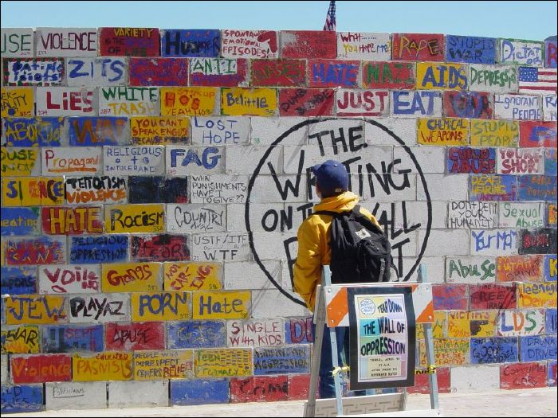
The Writing on the Wall Project began at the University of Utah with the Human Issues Education Committee (HIEC). The HIEC’s members are students and staff from the residence halls. The HIEC was initiated in the Fall of 2001 with the purpose of developing educational programs and events on human issues for the on-campus community to raise awareness and create a deeper impact through the shared experiences of participants.

The HIEC was approached by LaDon Roeder, the creator and author of The Writing on the Wall Project, to bring the idea into reality. AS the Writing on the Wall Project caught on and the event grew into an entire week of activities, invitations to student leaders, staff, and faculty across the campus were made and the Wall Project Planning Committee was formed.

From the University of Utah, The Writing on the Wall Project has spread throughout the country. It has been done from Eastern Washington University in Cheney, Washington to Northeastern University in Boston, Massachusetts.

What is the Wall Project?

The goal of the project is to confront the issues of awareness, oppression and discrimination by building a wall that is approximately 10 feet tall and over 35 feet long. Through the act of literally constructing a cinderblock wall-constructing our oppression of others- and bringing down this structure- participants in this event are reminded of the need to act personally and experience the power that collaboration can create positive change for the future.

The wall, which is made out of cinderblocks and eyebolts, is a physical representation of our oppression of others throughout human history; it symbolizes the barrier that prevents us as individuals, races, genders and cultures from connecting in our shared humanity. Each brick is a moment in an individual’s experience or in our collective history of an act of discrimination, an outrage, a crime or an act of inhumanity; a painted, drawn or written representation of this act is placed on a cinder block brick. Each brick taking its place in the Wall; this shameful monument is erected so that we remember and witness clearly the writing on the wall. By seeing all of these acts of inhumanity in the form of a wall we more easily recognize and understand that the atrocities together are what create barriers that separate us. By building the wall on the U of I campus we have a physical record that must be acknowledged and which all communities must face

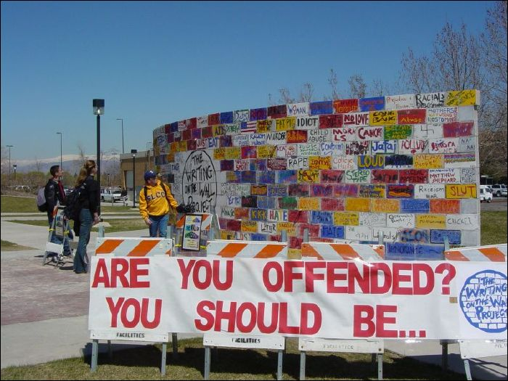
Timeline
- January
  - Solicit groups and organizations for materials and funds

- February-March
  - Hold brick painting workshops
  - Approach organizations to facilitate End Discrimination Week Programs the week of the wall
- April 3-10, 2004
  - 3rd: Wall constructed
  - 4th-8th: End Discrimination Programs held
  - 9th: Featured speaker and the wall is pulled down
  - 10th: The wall remains will be removed

Bricks and Painting Workshops

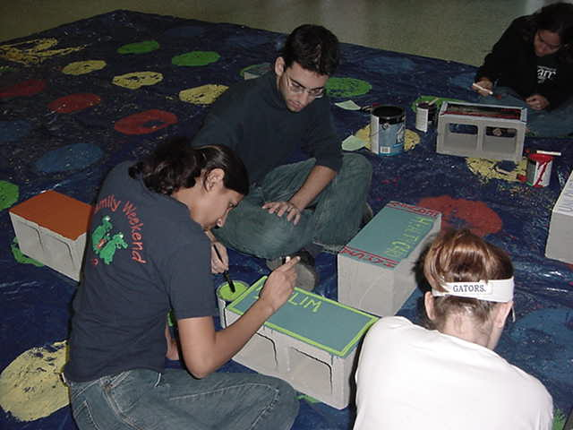
Prior to the construction there are 300 cinderblocks that need to be painted. Although some of the bricks will be painted by Iota Psi Phi, Inc in order to provide a diverse combination of events and symbols, the majority of the bricks will be painted by others in five brick painting sessions that will be available throughout the months prior to the event.

End Discrimination Week Programs

An organization can sponsor an event to occur during End Discrimination Week. The members of the organization can identify an issue on which to educate and raise community awareness on.

Some examples of an event are:
- Host a speaker on the life of Gandhi, Martin Luther King, or other heroes of human rights
- Plan a “Day of Silence” event
- Coordinate the showing of a movie or media presentation
- Plan and host an open mic night on human issues poetry (such as slam poetry)
- Hold an event in recognition of victims of violence
Presentations can be done by individual organizations or as a collaborative effort of several organizations. When advertising for the Wall Project these events will also be included.
Wall Construction

At the University of Utah it took two masons six hours to construct the wall. The wall is mortared together with the eyebolts placed throughout the wall during construction. In order to shield the concrete that the wall will be built on, sheets of plywood are placed in front of the wall. There has never been any structural damage during the Wall Project.

The prospective site for the Writing on the Wall Project is the Commons Plaza. The wall will not block the flow of traffic in the plaza. This was verified after measuring out the dimensions of the wall and applying these measurements to the Commons. On the following page is a series of photos that show these measurements.

Safety and Security

Besides the fact that the wall will be built by a licensed mason, there are other security measures that will be taken. The wall is built at a slight curve to ensure stability. The wall itself will be protected 24 hours a day starting with the construction of the wall and ending with the removal of the rumble. Since the wall will be controversial, security will ensure that the wall will not be vandalized and will remain standing until its intended destruction. There is also the possibility of a safety zone surrounding the wall. A 12 foot safety zone can be provided for this project. However, several schools have not provided this safety zone.

Ceremony

On Friday, April 9th there will be a speaker to conclude the Writing on the Wall Project. Introduced by a member of Iota Psi Phi this guest speaker will address those in attendance about a relevant topic. Invitations to this ceremony will be given to student leaders, staff, faculty and the press. During the ceremony, student organizations can have tables in the plaza with information about their groups.

Tearing Down the Wall

The assembly of the wall allows for a dozen eyebolts in the construction. Over a thousand feet of rope will be attached to these eyebolts. When all the ropes are pulled in unison, the wall will collapse. This represents how when we work together we can overcome and destroy the hatred and negativity in the world. After the wall collapses, participants will be encouraged to take a piece of the wall to remind them to get involved and to continue to make a difference. The rubble from the wall will remain throughout Friday and will be removed Saturday afternoon.
Commons Pictures

Advertising

There are three phases to this project that will need to be advertised. Since the project will rely on others to paint the cinderblocks, it is necessary to attract them to the painting sessions. Along with this, we would like to see the wall and the programs that will go along with it to be successful as well. Listed below are some methods that we plan on utilizing:

- Attending organization meetings as well as visiting different living groups.
Some of the groups that we plan on visiting are the Associated Students of The University of Idaho (ASUI) Senate, Residence Hall Association (RHA) and the halls under it, Interfraternity Council (IFC) and the individual fraternities, Panhellenic Council and the individual sororities, Gay Straight Alliance (GSA), Feminist Led Activist Movement to Empower (FLAME), and the organizations under the Office of Multicultural Affairs (OMA).
- Fliers and Posters
Fliers and Posters will be used to advertise many parts of the project. Fliers will be given out to organizations detailing the different parts of the project, including the brick painting sessions and the events that will occur along side the wall. Although large posters will be used to advertise all aspects of the wall, they will be in areas where they will be seen by large numbers of people. Some examples are the Commons Food Court and the Wallace Food Court in the Residence Halls.
- Radio Stations and Television Stations
We feel that it is important to attract individuals from the Moscow community as well as the campus. Local and campus radio stations are one way that we will be able to do this.
- Word of Mouth
When the wall is a physical presence on campus, it will draw the attention of students, staff and faculty. Since it will be such a large structure, people will talk about the project and share it with others.
- Working with Faculty and classes
We hope to work with professors to encourage their students to attend the brick painting sessions. We hope that some professors will give students extra credit for attending the brick painting sessions.
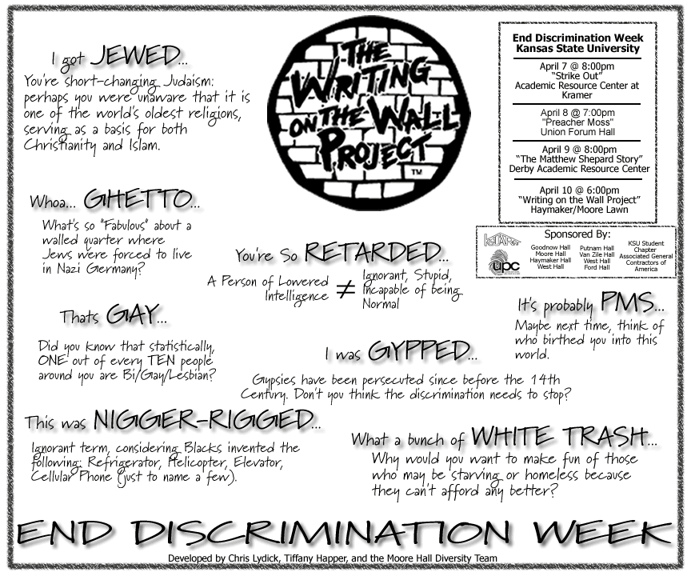

Proposed Budget

300 bricks (range from $1.29-1.59) 400.00
Bolts and steel plates 50.00
Paint and painting supplies 200.00
Masonry Time 200.00
Ply wood and rope 100.00
Sound 150.00
Publicity 400.00
Miscellaneous 200.00
Total 1700.00

Contact Information
Jennifer Dion
Iota Psi Phi, Inc President and Wall Chair
Phone: 885-8789
Address: 1080 W 6th St
MSC 1701
Moscow ID 83843
E-mail: dion0538@uidaho.edu
Erica Hauk
Iota Psi Phi, Inc Vice President
Phone: 885-8790
Address: 1080 W. 6th St
MSC 1632
Moscow, ID, 83843
E-mail: hauk0806@uidaho.edu

